МИНИСТЕРСТВО НАУКИ И ВЫСШЕГО ОБРАЗОВАНИЯ РОССИЙСКОЙ ФЕДЕРАЦИИ

Федеральное государственное бюджетное образовательное учреждение

высшего образования

«**Вятский государственный университет**»

**(ФГБОУ ВО «ВятГУ»)**

Факультет автоматики и вычислительной техники

Кафедра ЭВМ

Отчёт

### Лабораторная работа № 4 по дисциплине

«Арифметико-логические основы вычислительной техники»

«Микропрограммное управление»

Выполнил студент группы ИВТб-1301 ________________/Жеребцов К. А.

## Проверил преподаватель ________________ /Коржавина А. С.

Киров 2021

***Цель:***

Выполнить деление 2-мя способами в ПК с восстановлением и без восстановления остатков.

***Задание:***

Необходимо создать микропрограммы для выполнения умножения.

***1 способ:***

1. ***ВО***

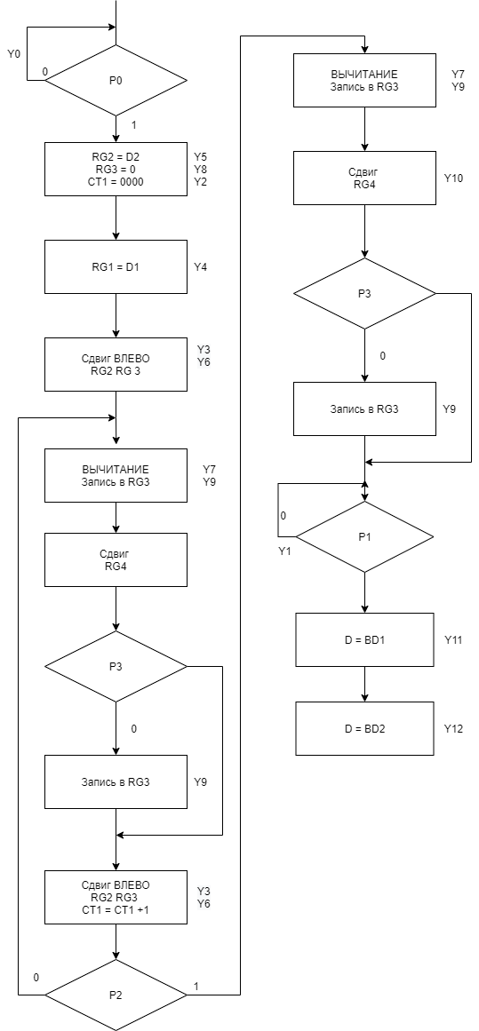

|  |  |  |  |  |  |  |  |  |  |  |  |  |  |
| --- | --- | --- | --- | --- | --- | --- | --- | --- | --- | --- | --- | --- | --- |
|  | y12 | y11 | y10 | y9 | y8 | y7 | y6 | y5 | y4 | y3 | y2 | y1 | y0 |
| 1 | 0 | 0 | 0 | 0 | 0 | 0 | 0 | 0 | 0 | 0 | 0 | 0 | 1 |
| 2 | 0 | 0 | 0 | 0 | 1 | 0 | 0 | 1 | 0 | 0 | 2 | 0 | 0 |
| 3 | 0 | 0 | 0 | 0 | 0 | 0 | 0 | 0 | 1 | 0 | 0 | 0 | 0 |
| 4 | 0 | 0 | 0 | 0 | 0 | 0 | 1 | 0 | 0 | 1 | 0 | 0 | 0 |
| 5 | 0 | 0 | 0 | 1 | 0 | 1 | 0 | 0 | 0 | 0 | 0 | 0 | 0 |
| 6 | 0 | 0 | 1 | 0 | 0 | 0 | 0 | 0 | 0 | 0 | 0 | 0 | 0 |
| 7 | 0 | 0 | 0 | 1 | 0 | 0 | 0 | 0 | 0 | 0 | 0 | 0 | 0 |
| 8 | 0 | 0 | 0 | 0 | 0 | 0 | 0 | 0 | 0 | 0 | 0 | 1 | 0 |
| 9 | 0 | 1 | 0 | 0 | 0 | 0 | 0 | 0 | 0 | 0 | 0 | 0 | 0 |
| 10 | 1 | 0 | 0 | 0 | 0 | 0 | 0 | 0 | 0 | 0 | 0 | 0 | 0 |

|  |  |
| --- | --- |
|  | Код в 16 СС |
|  | 0001 |
|  | 0124 |
|  | 0010 |
|  | 0048 |
|  | 0280 |
|  | 0400 |
|  | 0200 |
|  | 0002 |
|  | 0800 |
|  | 1000 |

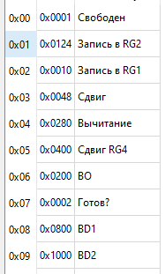

1. ***без ВО***

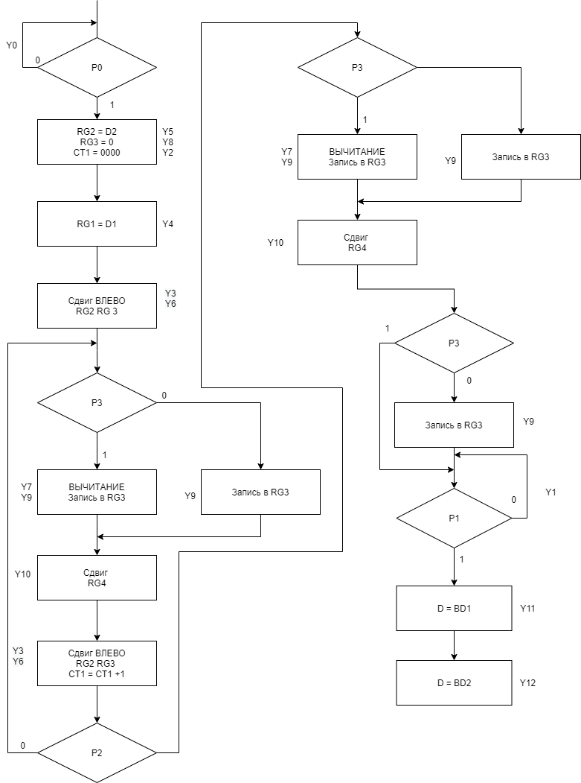

|  |  |  |  |  |  |  |  |  |  |  |  |  |  |
| --- | --- | --- | --- | --- | --- | --- | --- | --- | --- | --- | --- | --- | --- |
|  | y12 | y11 | y10 | y9 | y8 | y7 | y6 | y5 | y4 | y3 | y2 | y1 | y0 |
| 1 | 0 | 0 | 0 | 0 | 0 | 0 | 0 | 0 | 0 | 0 | 0 | 0 | 1 |
| 2 | 0 | 0 | 0 | 0 | 1 | 0 | 0 | 1 | 0 | 0 | 2 | 0 | 0 |
| 3 | 0 | 0 | 0 | 0 | 0 | 0 | 0 | 0 | 1 | 0 | 0 | 0 | 0 |
| 4 | 0 | 0 | 0 | 0 | 0 | 0 | 1 | 0 | 0 | 1 | 0 | 0 | 0 |
| 5 | 0 | 0 | 0 | 1 | 0 | 1 | 0 | 0 | 0 | 0 | 0 | 0 | 0 |
| 6 | 0 | 0 | 0 | 1 | 0 | 0 | 0 | 0 | 0 | 0 | 0 | 0 | 0 |
| 7 | 0 | 0 | 1 | 0 | 0 | 0 | 0 | 0 | 0 | 0 | 0 | 0 | 0 |
| 8 | 0 | 0 | 0 | 0 | 0 | 0 | 0 | 0 | 0 | 0 | 0 | 1 | 0 |
| 9 | 0 | 1 | 0 | 0 | 0 | 0 | 0 | 0 | 0 | 0 | 0 | 0 | 0 |
| 10 | 1 | 0 | 0 | 0 | 0 | 0 | 0 | 0 | 0 | 0 | 0 | 0 | 0 |

|  |  |
| --- | --- |
|  | Код в 16 СС |
| 1 | 0001 |
| 2 | 0124 |
| 3 | 0010 |
| 4 | 0048 |
| 5 | 0280 |
| 6 | 0200 |
| 7 | 0400 |
| 8 | 0002 |
| 9 | 0800 |
| 10 | 1000 |

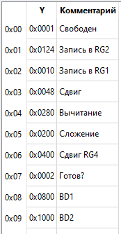

***2 способ:***

1. ***ВО***

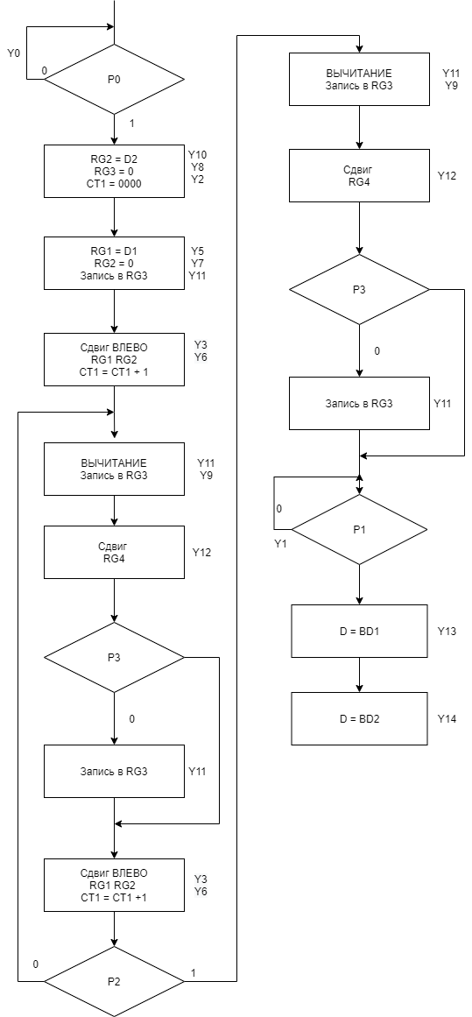

|  |  |  |  |  |  |  |  |  |  |  |  |  |  |  |  |
| --- | --- | --- | --- | --- | --- | --- | --- | --- | --- | --- | --- | --- | --- | --- | --- |
|  | y14 | y13 | y12 | y11 | y10 | y9 | y8 | y7 | y6 | y5 | y4 | y3 | y2 | y1 | y0 |
| 1 | 0 | 0 | 0 | 0 | 0 | 0 | 0 | 0 | 0 | 0 | 0 | 0 | 0 | 0 | 1 |
| 2 | 0 | 0 | 0 | 0 | 1 | 0 | 1 | 0 | 0 | 0 | 0 | 0 | 2 | 0 | 0 |
| 3 | 0 | 0 | 0 | 1 | 0 | 0 | 0 | 1 | 0 | 1 | 0 | 0 | 0 | 0 | 0 |
| 4 | 0 | 0 | 0 | 0 | 0 | 0 | 0 | 0 | 1 | 0 | 0 | 1 | 0 | 0 | 0 |
| 5 | 0 | 0 | 0 | 1 | 0 | 1 | 0 | 0 | 0 | 0 | 0 | 0 | 0 | 0 | 0 |
| 6 | 0 | 0 | 1 | 0 | 0 | 0 | 0 | 0 | 0 | 0 | 0 | 0 | 0 | 0 | 0 |
| 7 | 0 | 0 | 0 | 1 | 0 | 0 | 0 | 0 | 0 | 0 | 0 | 0 | 0 | 0 | 0 |
| 8 | 0 | 0 | 0 | 0 | 0 | 0 | 0 | 0 | 0 | 0 | 0 | 0 | 0 | 1 | 0 |
| 9 | 0 | 1 | 0 | 0 | 0 | 0 | 0 | 0 | 0 | 0 | 0 | 0 | 0 | 0 | 0 |
| 10 | 1 | 0 | 0 | 0 | 0 | 0 | 0 | 0 | 0 | 0 | 0 | 0 | 0 | 0 | 0 |

|  |  |
| --- | --- |
|  | Код в 16 СС |
| 1 | 0001 |
| 2 | 0504 |
| 3 | 08a0 |
| 4 | 0048 |
| 5 | 0a00 |
| 6 | 1000 |
| 7 | 0800 |
| 8 | 0002 |
| 9 | 2000 |
| 10 | 4000 |

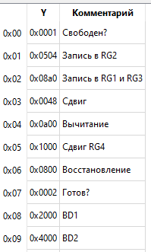

1. ***без ВО***

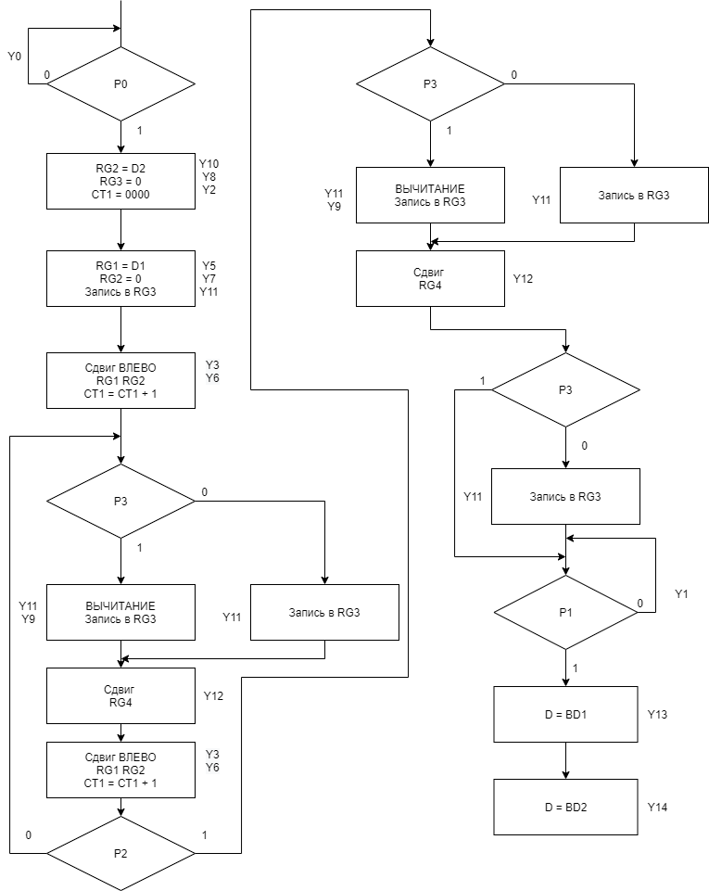

|  |  |  |  |  |  |  |  |  |  |  |  |  |  |  |  |
| --- | --- | --- | --- | --- | --- | --- | --- | --- | --- | --- | --- | --- | --- | --- | --- |
|  | y14 | y13 | y12 | y11 | y10 | y9 | y8 | y7 | y6 | y5 | y4 | y3 | y2 | y1 | y0 |
| 1 | 0 | 0 | 0 | 0 | 0 | 0 | 0 | 0 | 0 | 0 | 0 | 0 | 0 | 0 | 1 |
| 2 | 0 | 0 | 0 | 0 | 1 | 0 | 1 | 0 | 0 | 0 | 0 | 0 | 2 | 0 | 0 |
| 3 | 0 | 0 | 0 | 1 | 0 | 0 | 0 | 1 | 0 | 1 | 0 | 0 | 0 | 0 | 0 |
| 4 | 0 | 0 | 0 | 0 | 0 | 0 | 0 | 0 | 1 | 0 | 0 | 1 | 0 | 0 | 0 |
| 5 | 0 | 0 | 0 | 1 | 0 | 1 | 0 | 0 | 0 | 0 | 0 | 0 | 0 | 0 | 0 |
| 6 | 0 | 0 | 0 | 1 | 0 | 0 | 0 | 0 | 0 | 0 | 0 | 0 | 0 | 0 | 0 |
| 7 | 0 | 0 | 1 | 0 | 0 | 0 | 0 | 0 | 0 | 0 | 0 | 0 | 0 | 0 | 0 |
| 8 | 0 | 0 | 0 | 0 | 0 | 0 | 0 | 0 | 0 | 0 | 0 | 0 | 0 | 1 | 0 |
| 9 | 0 | 1 | 0 | 0 | 0 | 0 | 0 | 0 | 0 | 0 | 0 | 0 | 0 | 0 | 0 |
| 10 | 1 | 0 | 0 | 0 | 0 | 0 | 0 | 0 | 0 | 0 | 0 | 0 | 0 | 0 | 0 |

|  |  |
| --- | --- |
|  | Код в 16 СС |
| 1 | 0001 |
| 2 | 0504 |
| 3 | 08a0 |
| 4 | 0048 |
| 5 | 0a00 |
| 6 | 0800 |
| 7 | 1000 |
| 8 | 0002 |
| 9 | 2000 |
| 10 | 4000 |

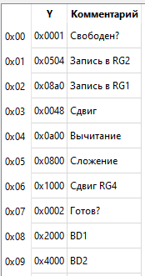

***Вывод:***

В ходе лабораторной работы были проработаны 2 способа деления в прямом коде с восстановлением остатков и без него. Также были созданы микропрограммы для проверки алгоритмов деления разными способами. Было выявлено, что алгоритмы деления разными способами схожи и отличаются лишь деталями.